**PARENTS CHILDREN ACTIVITIES**

**ACADEMICS**

**For Age Group 4-5 Years:**

1. **Alphabet Treasure Hunt**

**Description: Hide cards with letters around the house. The child has to find them and match them with objects starting with that letter.**

**Materials: Alphabet cards, small objects (optional).**

**Time Duration: 20-30 minutes.**

**Video:** [**https://youtu.be/wuz4ZUuVTNI?si=9TW0Y4UKEwLgJIcY**](https://youtu.be/wuz4ZUuVTNI?si=9TW0Y4UKEwLgJIcY)

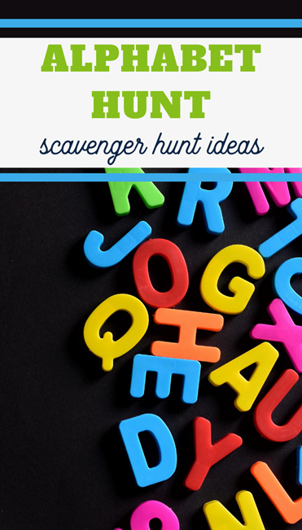

1. **Shape Sorting Adventure**

**Description: Mix shapes of different colors and sizes. The child sorts and names them.**

**Materials: Cut-out shapes in paper/cardboard (circle, square, triangle, etc.).**

**Time Duration: 20 minutes.**

**Video:** [**https://youtu.be/hjFlTU6AEYc?si=dUK9zbtZRlaX420l**](https://youtu.be/hjFlTU6AEYc?si=dUK9zbtZRlaX420l)

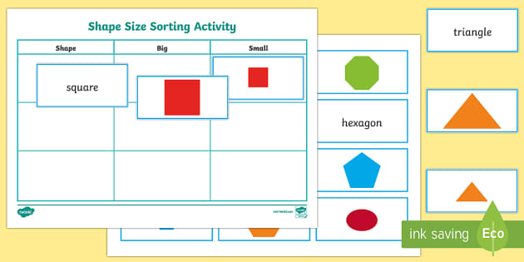

1. **Counting with Toys**

**Description: Ask your child to count toys or arrange them in groups of 2s, 5s, or 10s.**

**Materials: Any small toys or blocks.**

**Time Duration: 15-20 minutes.**

**Video:** [**https://youtu.be/MBPhqzWw0xY?si=MNC1LPmyTWuN8v43**](https://youtu.be/MBPhqzWw0xY?si=MNC1LPmyTWuN8v43)

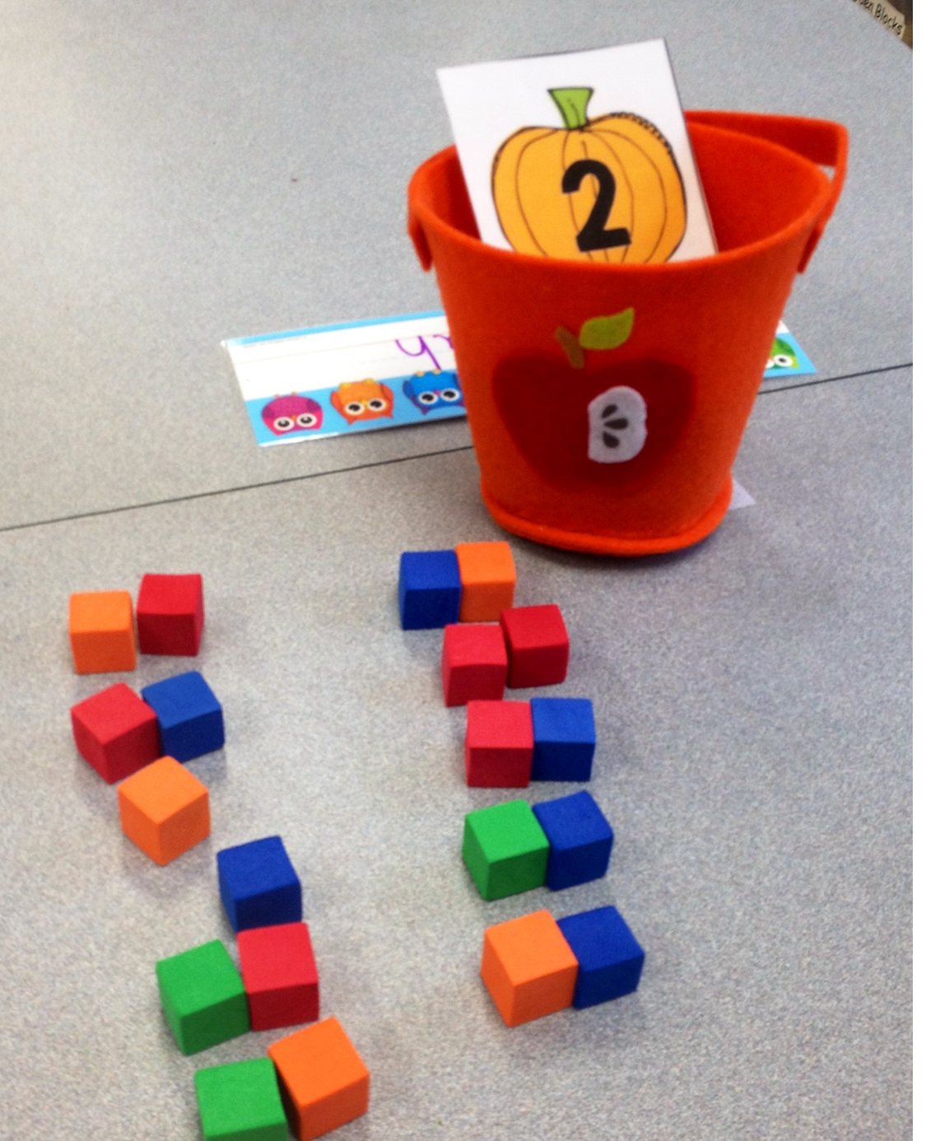

1. **Rainbow Science**

**Description: Create a rainbow by mixing water, oil, and food colouring in a glass jar. Discuss colours and density.**

**Materials: Jar, water, oil, food colouring.**

**Time Duration: 30 minutes.**

**Video:** [**https://youtu.be/718LXQUKKIM?si=jsFyoPJ7pE8_73RC**](https://youtu.be/718LXQUKKIM?si=jsFyoPJ7pE8_73RC)

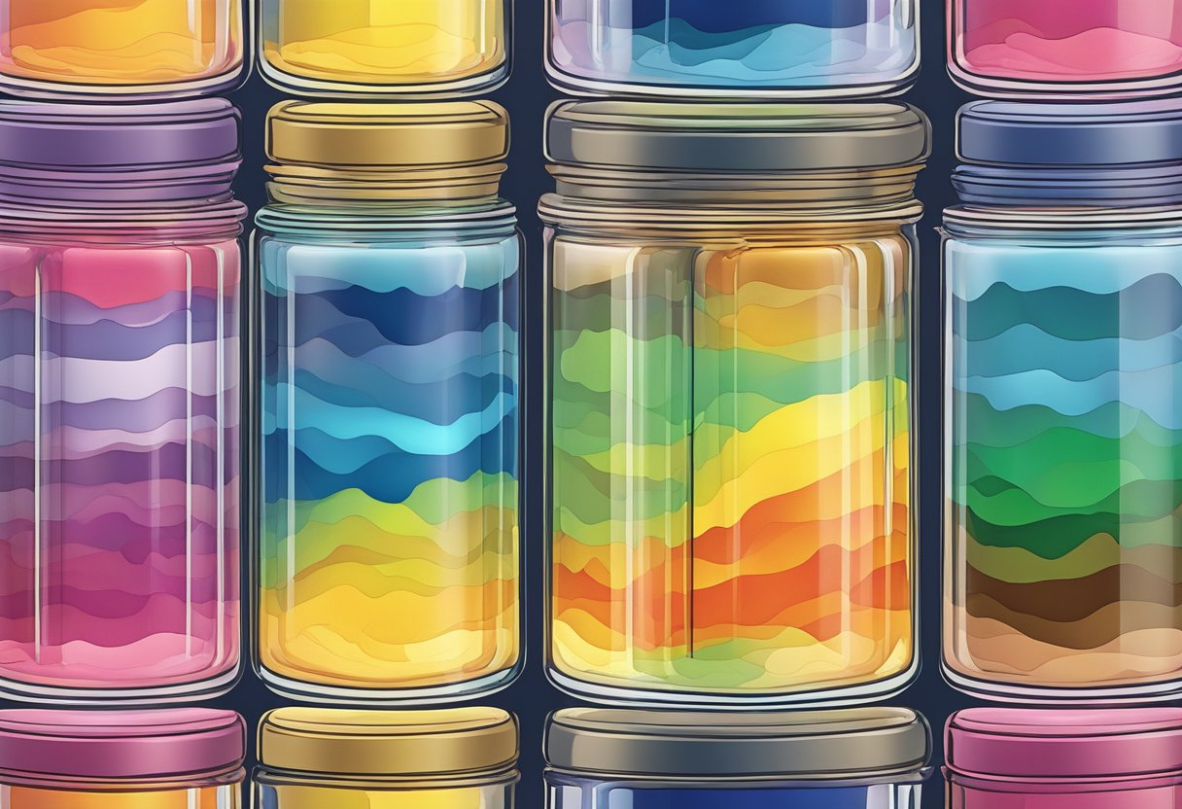

1. **Storytelling with Puppets**

**Description: Create simple paper puppets and narrate a story.**

**Materials: Paper, markers, glue, sticks.**

**Time Duration: 30-40 minutes.**

[**https://youtu.be/SOnl6BGoS_M?si=aOQ-AZQhyWbnwKFK**](https://youtu.be/SOnl6BGoS_M?si=aOQ-AZQhyWbnwKFK)

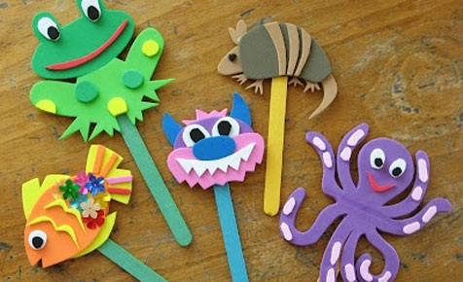

1. **Big and Small Hunt**

**Description: Ask the child to find objects that are big and small around the house.**

**Materials: Everyday household items.**

**Time Duration: 15 minutes.**

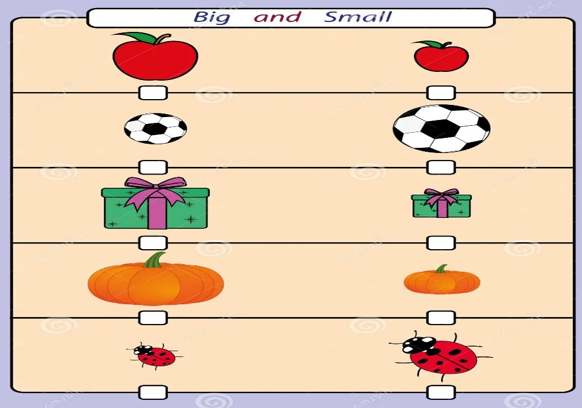

1. **Sing the Numbers**

**Description: Sing a fun song about numbers or count along to music.**

**Materials: None or a recorded song.**

**Time Duration: 10-15 minutes.**

**Video:** [**https://youtu.be/DR-cfDsHCGA?si=Thz6Vlz0slnvqUrU**](https://youtu.be/DR-cfDsHCGA?si=Thz6Vlz0slnvqUrU)

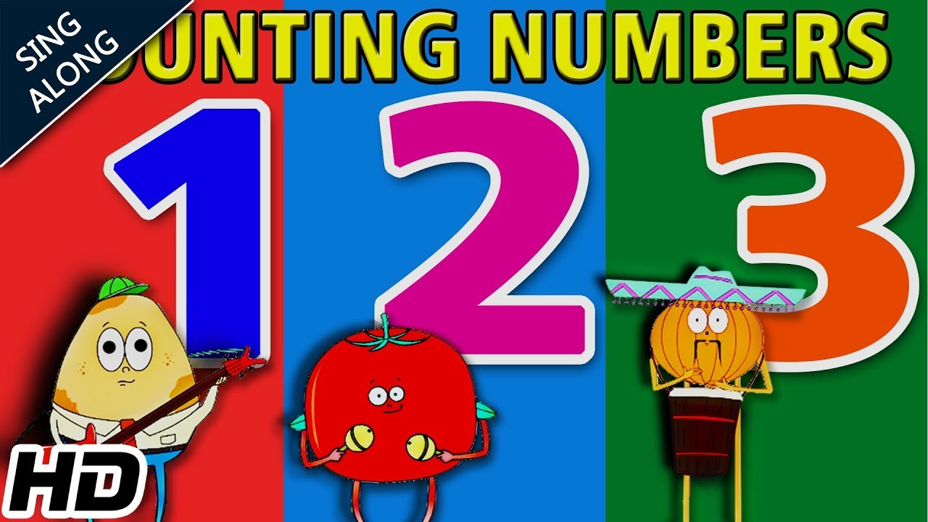

1. **Texture Touch Game**

**Description: Place objects with different textures in a box. The child identifies them by touch.**

**Materials: Cotton, sandpaper, cloth, etc.**

**Time Duration: 20 minutes.**

**Video:** [**https://youtu.be/BT0UfyuNAzo?si=7NPYpGHU9e9TkrwB**](https://youtu.be/BT0UfyuNAzo?si=7NPYpGHU9e9TkrwB)

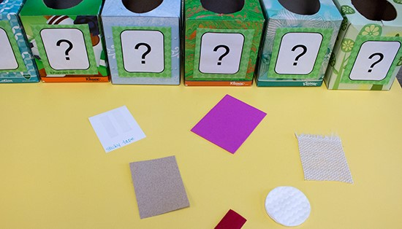

1. **Pattern Play**

**Description: Create patterns with blocks or beads and ask the child to continue them.**

**Materials: Beads, blocks, or small toys.**

**Time Duration: 25 minutes.**

**Video:** [**https://youtube.com/shorts/Y55wc9b-t5A?si=TeJ7b9aqb4AbDnvU**](https://youtube.com/shorts/Y55wc9b-t5A?si=TeJ7b9aqb4AbDnvU)

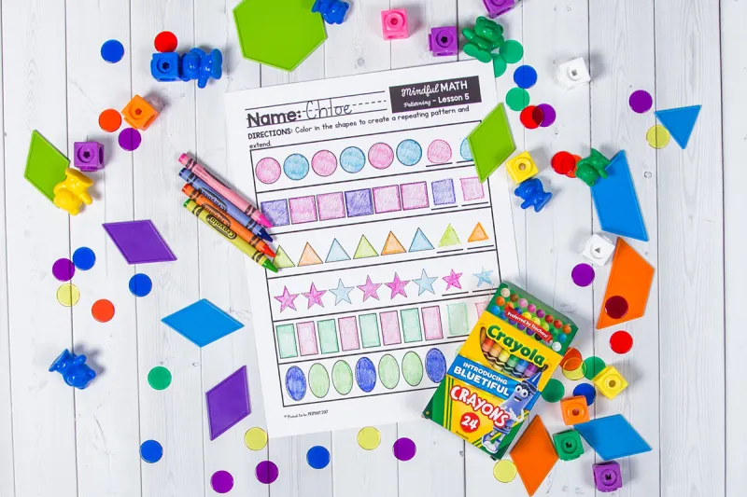

1. **Colour Sorting**

**Description: Sort objects by color into separate bowls.**

**Materials: Colourful objects, bowls.**

**Time Duration: 20 minutes.**

**Video:** [**https://youtu.be/CqPF8VfZOr8?si=vsnTGd6DtCR8W3rg**](https://youtu.be/CqPF8VfZOr8?si=vsnTGd6DtCR8W3rg)

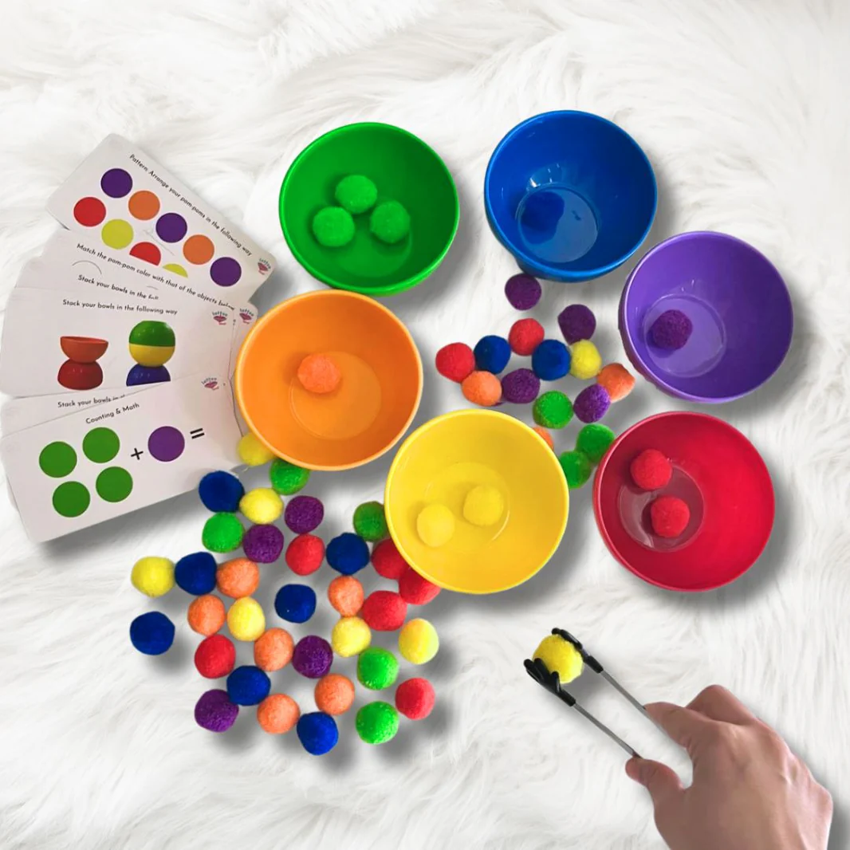

1. **Make a Nature Collage**

**Description: Collect leaves, flowers, and twigs to create a collage.**

**Materials: Paper, glue, natural items.**

**Time Duration: 30 minutes.**

**Video:** [**https://youtu.be/NasyEuxzKMs?si=178M17rWbM07M6Oc**](https://youtu.be/NasyEuxzKMs?si=178M17rWbM07M6Oc)

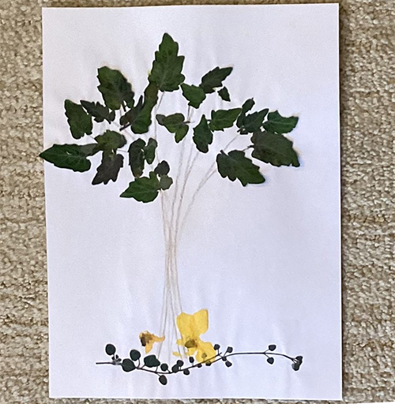

1. **Letter Tracing with Sand**

**Description: Use a tray of sand for the child to trace letters with their finger.**

**Materials: Tray, sand, or salt.**

**Time Duration: 20 minutes.**

**Video:** [**https://youtu.be/P5FyHpKpNMQ?si=SIWOAzPb93VBiGlK**](https://youtu.be/P5FyHpKpNMQ?si=SIWOAzPb93VBiGlK)

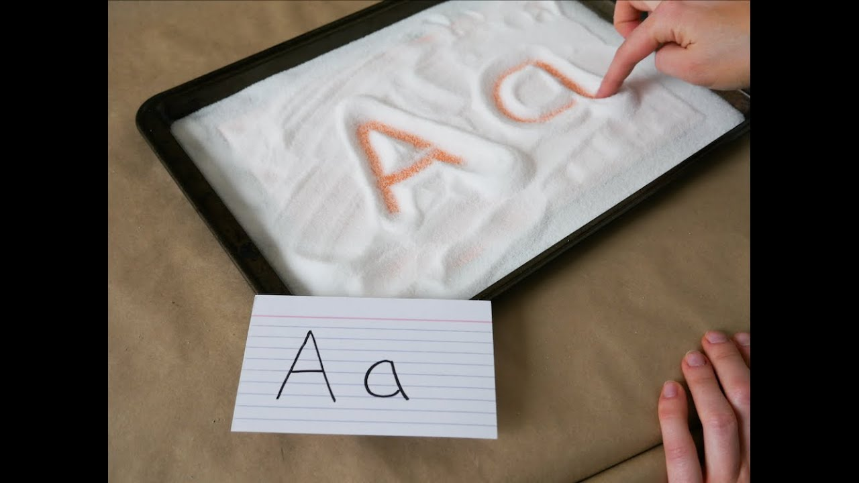

1. **Food Shape Fun**

**Description: Use cookie cutters to make shapes with bread or fruits.**

**Materials: Bread, fruit, cookie cutters.**

**Time Duration: 30 minutes.**

**Video:** [**https://youtu.be/MaeBbEcw7W4?si=ug7s81831h3qUgM1**](https://youtu.be/MaeBbEcw7W4?si=ug7s81831h3qUgM1)

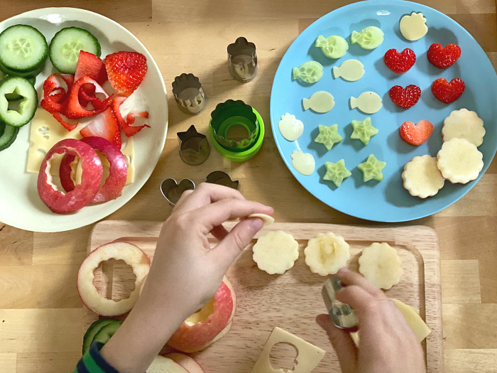

1. **Colour Mixing Lab**

**Description: Experiment with primary colours using water and food colouring to create new colours.**

**Materials: Food colouring, cups, water.**

**Time Duration: 20-30 minutes.**

**Video:** [**https://youtu.be/DJ6ahjpckaE?si=YNPfkToAFUZiPHFf**](https://youtu.be/DJ6ahjpckaE?si=YNPfkToAFUZiPHFf)

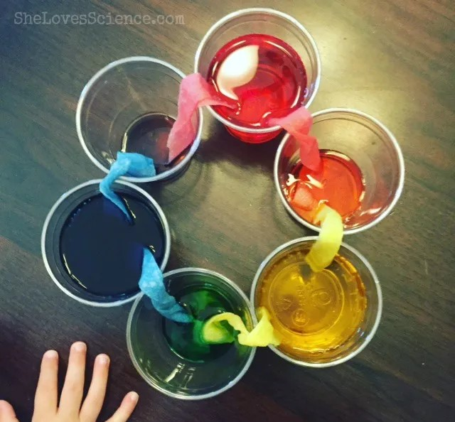

1. **Parent-Child Story Builder**

**Description: Take turns adding a sentence to build a fun story together.**

**Materials: None.**

**Time Duration: 20 minutes.**

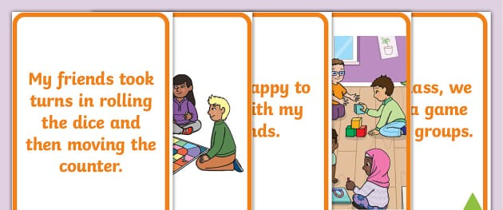

1. **Matching Memory Game**

**Description: Create pairs of cards with shapes, numbers, or animals and play a matching game.**

**Materials: Paper, markers.**

**Time Duration: 20-30 minutes.**

**Video:** [**https://youtu.be/5nq8KSf6KfA?si=Tjbaocg7kUzloMlC**](https://youtu.be/5nq8KSf6KfA?si=Tjbaocg7kUzloMlC)

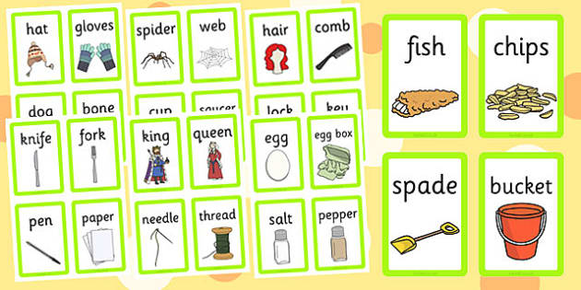

1. **DIY Animal Masks**

**Description: Create masks of favorite animals and role-play as those animals while learning their behaviors.**

**Materials: Paper plates, colors, glue, string.**

**Time Duration: 40 minutes.**

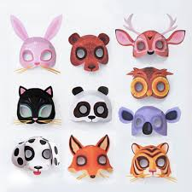

1. **Counting Picnic**

**Description: Set up a pretend picnic with snacks and toys, and count everything together (e.g., plates, fruits).**

**Materials: Snacks, plates, toys.**

**Time Duration: 30 minutes.**

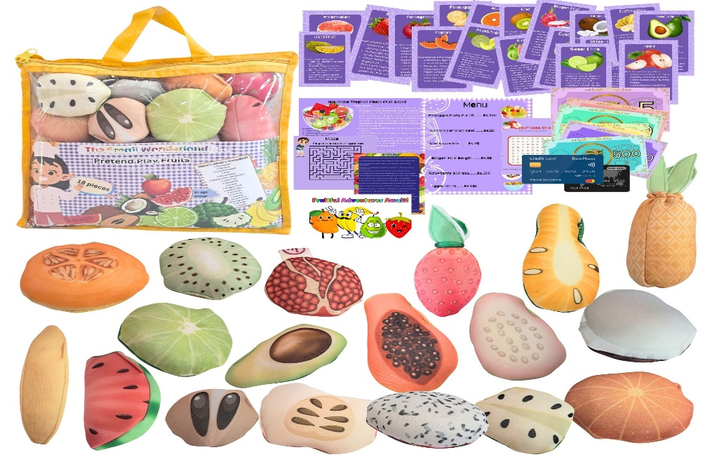

1. **Shape Collage**

**Description: Cut out shapes and help your child make a picture using circles, squares, etc.**

**Materials: Colored paper, glue, scissors.**

**Time Duration: 30 minutes.**

**Video:** [**https://youtu.be/sJJwwlfkPH4?si=LAXdLejF2rZwEQSU**](https://youtu.be/sJJwwlfkPH4?si=LAXdLejF2rZwEQSU)

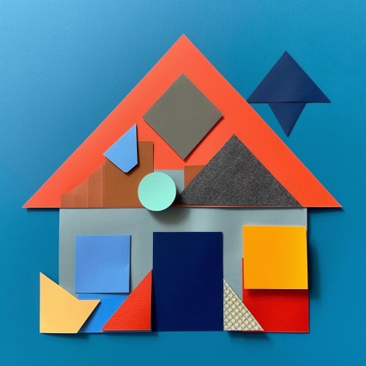

1. **Shadow Puppets Show**

**Description: Use your hands or cutouts to create shadow puppets and narrate a story.**

**Materials: Flashlight, paper cutouts.**

**Time Duration: 20-25 minutes.**

**Video:** [**https://youtu.be/yqmXAm1Cw3k?si=oTmJkrB8g3TdzkG_**](https://youtu.be/yqmXAm1Cw3k?si=oTmJkrB8g3TdzkG_) 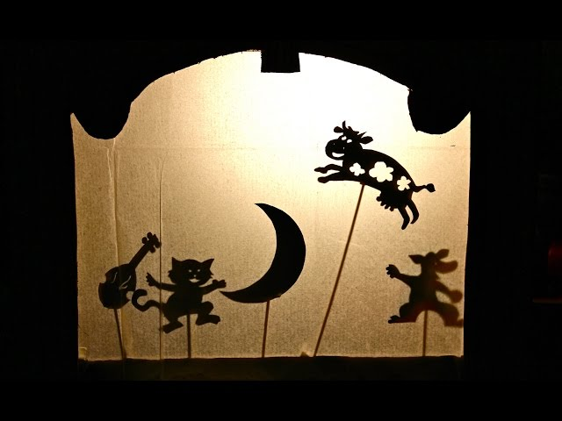

1. **Letter Hop Game**

**Description: Place letter cards on the floor, and the child hops to the correct letter when it is called out.**

**Materials: Letter cards.**

**Time Duration: 20 minutes.**

**Video:** [**https://youtu.be/3VntbDhoNdI?si=6ubtx6EEu4LBEaW1**](https://youtu.be/3VntbDhoNdI?si=6ubtx6EEu4LBEaW1)

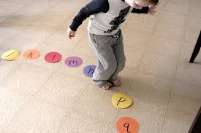

1. **Sound Safari**

**Description: Identify and mimic sounds of everyday items (like clock ticks or water dripping).**

**Materials: Household items.**

**Time Duration: 15-20 minutes.**

**Video:** [**https://youtu.be/IFNmUpTXhZY?si=DFtnVNUHvEk6tCgF**](https://youtu.be/IFNmUpTXhZY?si=DFtnVNUHvEk6tCgF) 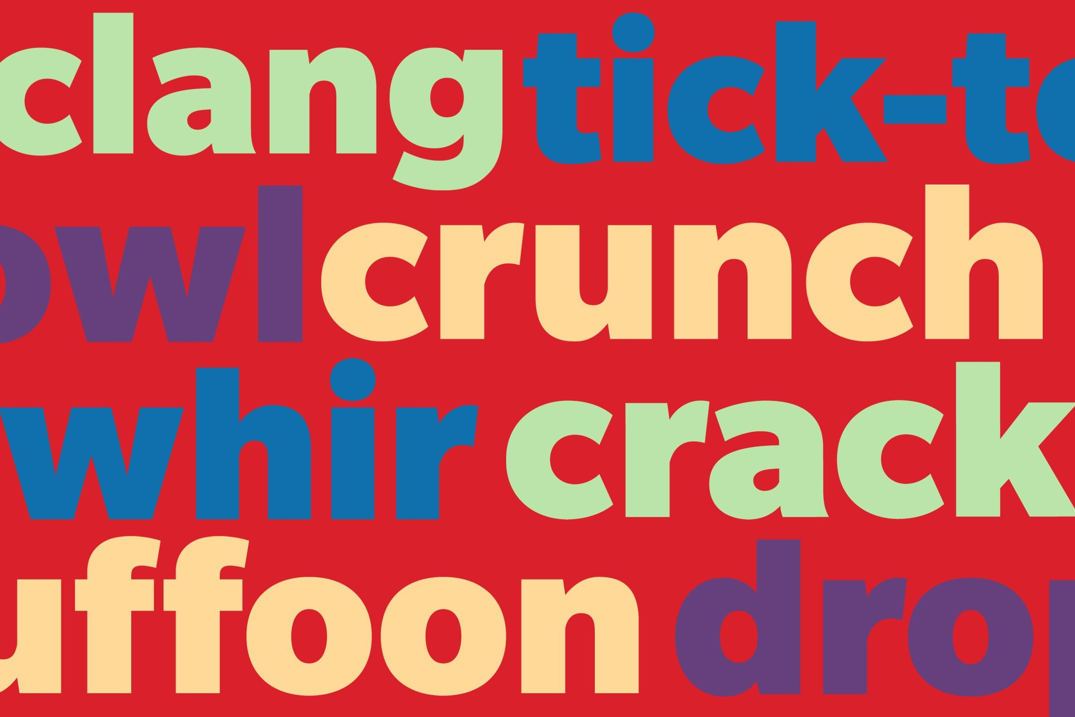

1. **Parent-Child Yoga**

**Description: Practice simple yoga poses together while naming body parts.**

**Materials: Yoga mat.**

**Time Duration: 15-20 minutes.**

**Video:** [**https://youtu.be/jO-jIFgGJ4k?si=0gWY8cMnwTJ7slAZ**](https://youtu.be/jO-jIFgGJ4k?si=0gWY8cMnwTJ7slAZ)

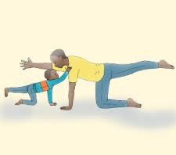

1. **DIY Balloon Rocket**

**Description: Create a balloon rocket and race them to learn about movement.**

**Materials: Balloons, string, tape, straw.**

**Time Duration: 20 minutes.**

**Video:** [**https://youtu.be/NXk0EAC8jAQ?si=EIpA_E2KhzKW3jTU**](https://youtu.be/NXk0EAC8jAQ?si=EIpA_E2KhzKW3jTU)

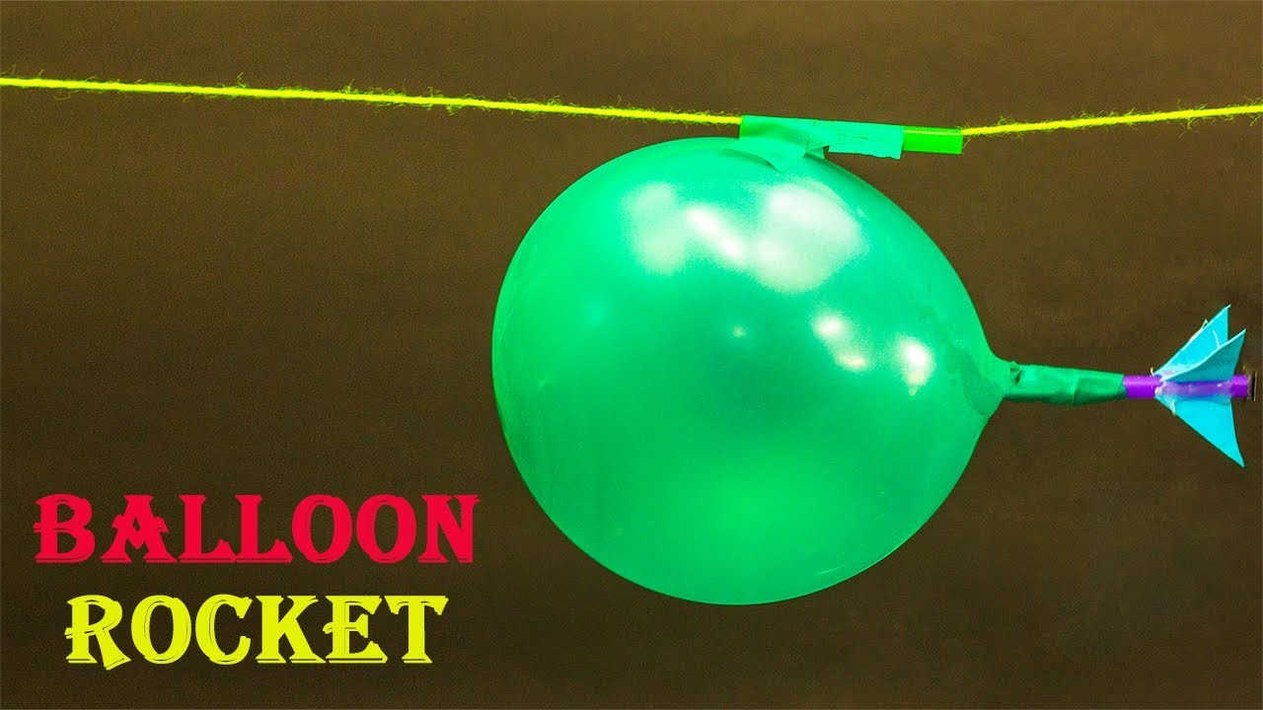

**For Age Group 6-8 Years**

* 1. **DIY Crossword Puzzle**

**Description: Create a custom crossword with words your child is learning in school.**

**Materials: Paper, markers.**

**Time Duration: 30 minutes.**

**Video:** [**https://youtu.be/ckVjv0YKNZY?si=l3qi5i-oLYkahDfC**](https://youtu.be/ckVjv0YKNZY?si=l3qi5i-oLYkahDfC)

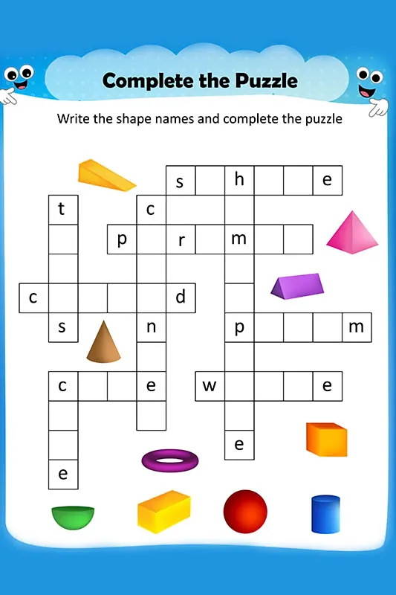

* 1. **Science in the Kitchen**

**Description: Explore kitchen experiments like dissolving sugar in water or making ice cubes melt faster.**

**Materials: Everyday kitchen items.**

**Time Duration: 30 minutes.**

**Video:** [**https://youtu.be/OVjNS1hSEeo?si=5qKGwatd0Am1iRuz**](https://youtu.be/OVjNS1hSEeo?si=5qKGwatd0Am1iRuz)

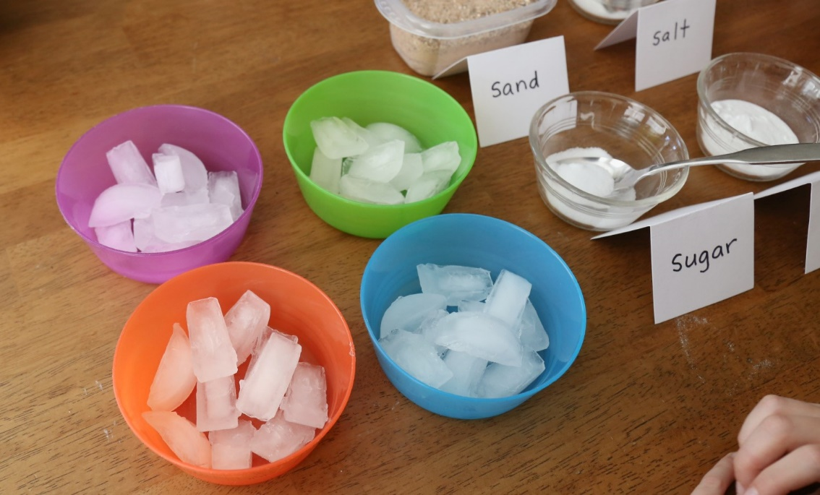

* 1. **Math Craft**

**Description: Create a craft project to practice multiplication or fractions.**

**Materials: Colored paper, glue.**

**Time Duration: 30 minutes.**

**Video:** [**https://youtube.com/shorts/9lbkdyKPCmw?si=dekEZ58-HJc2Oglp**](https://youtube.com/shorts/9lbkdyKPCmw?si=dekEZ58-HJc2Oglp)

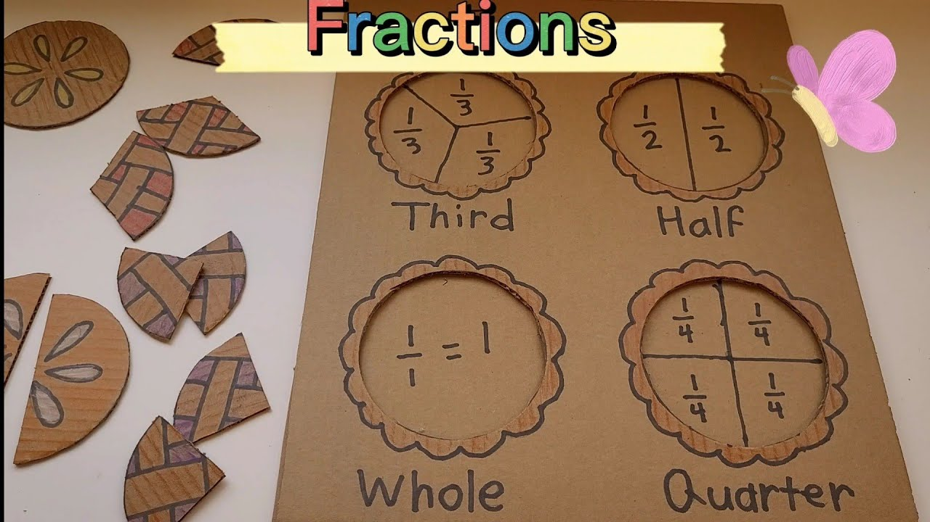

* 1. **DIY Bird Feeder**

**Description: Build a bird feeder and observe birds together.**

**Materials: Plastic bottle, string, bird seeds.**

**Time Duration: 40 minutes.**

**Video:** [**https://youtu.be/9DKzHucqY1I?si=gV_8LTMCVHplgATo**](https://youtu.be/9DKzHucqY1I?si=gV_8LTMCVHplgATo)

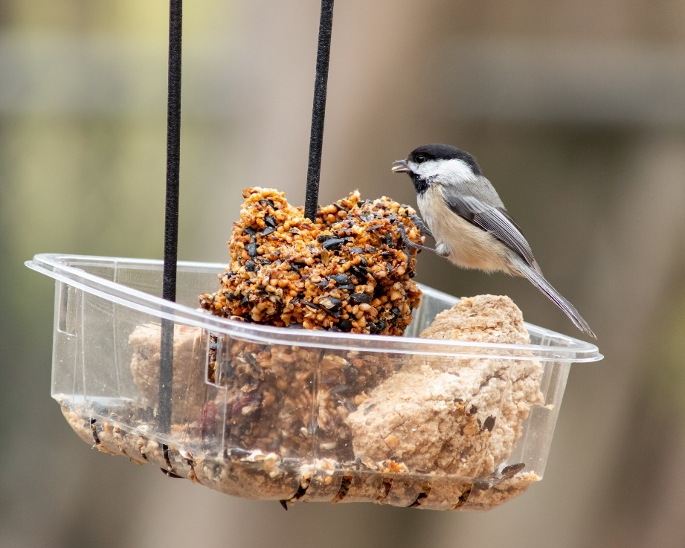

* 1. **Math Hopscotch**

**Description: Write equations in hopscotch squares, and solve them as you hop.**

**Materials: Chalk or tape.**

**Time Duration: 25-30 minutes.**

**Video:** [**https://youtu.be/Yf-vd1IettE?si=3e3cSBvhZxFSPLIe**](https://youtu.be/Yf-vd1IettE?si=3e3cSBvhZxFSPLIe)

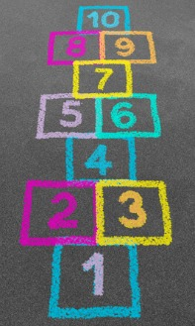

* 1. **Word Scramble Challenge**

**Description: Create scrambled words for your child to unscramble and guess.**

**Materials: Paper, pen.**

**Time Duration: 20 minutes.**

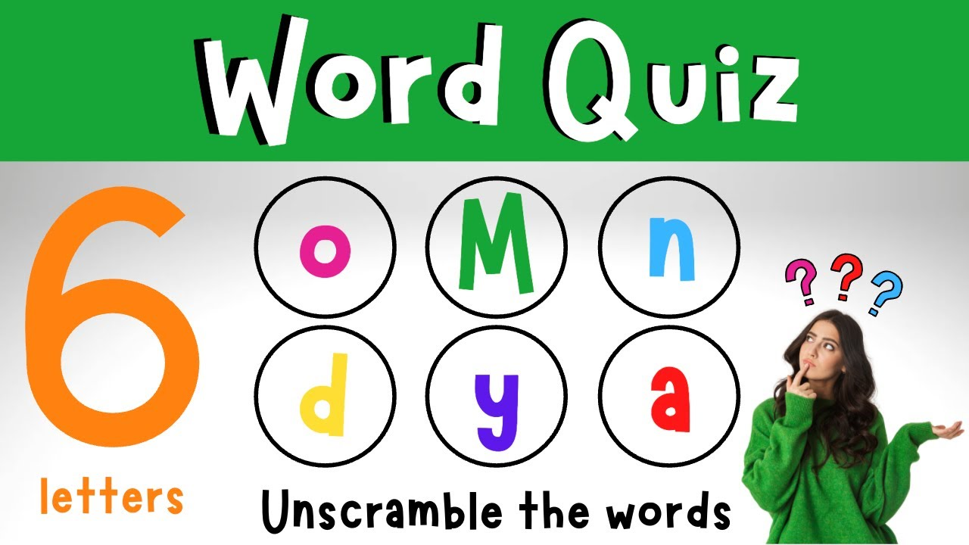

* 1. **DIY Magnetic Compass**

**Description: Teach your child how to make a simple compass using a magnetized needle.**

**Materials: Needle, magnet, cork, bowl of water.**

**Time Duration: 30 minutes.**

**Video:** [**https://youtu.be/SZUIpxZIeyA?si=Ha5D0Jn2reFujzfw**](https://youtu.be/SZUIpxZIeyA?si=Ha5D0Jn2reFujzfw)

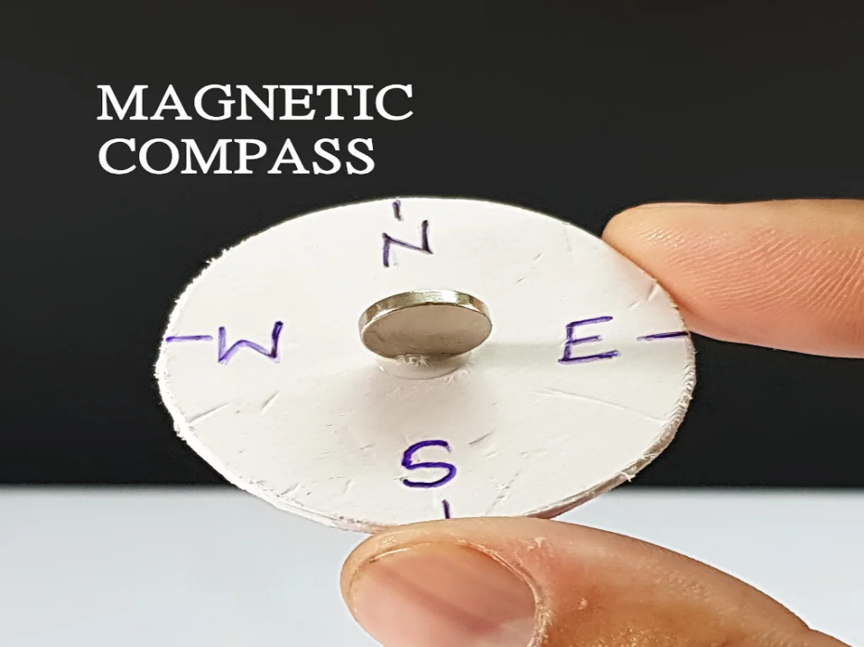

* 1. **Time Management Game**

**Description: Use a clock to play a game about estimating how long daily tasks take.**

**Materials: Clock or stopwatch.**

**Time Duration: 20 minutes.**

**Video:** [**https://youtu.be/kGd4OvEz7OY?si=EtL9VDYX26XP28e**](https://youtu.be/kGd4OvEz7OY?si=EtL9VDYX26XP28e) 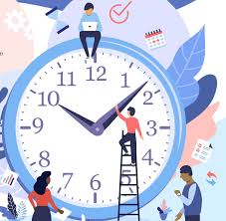

* 1. **DIY Code Breaker**

**Description: Create a simple code for your child to crack using math or letter patterns.**

**Materials: Paper, pen.**

**Time Duration: 30 minutes.**

**Video:** [**https://youtu.be/nD3B2RuqbZw?si=ybOgIDx1VuBKSJaJ**](https://youtu.be/nD3B2RuqbZw?si=ybOgIDx1VuBKSJaJ)

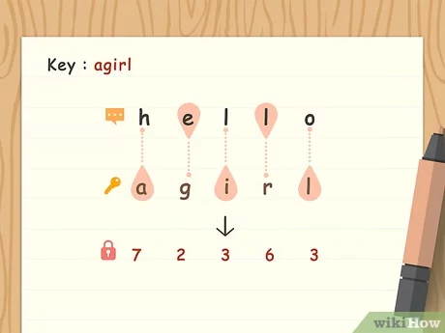

* 1. **Family Memory Map**

**Description: Draw a map of your house and label rooms or special spots. Ask your child to identify rooms and spots.**

**Materials: Paper, markers.**

**Time Duration: 30 minutes.**

**Video:** [**https://youtu.be/rKxnDEqCl2Y?si=yDpcN46jKmX2FxII**](https://youtu.be/rKxnDEqCl2Y?si=yDpcN46jKmX2FxII)

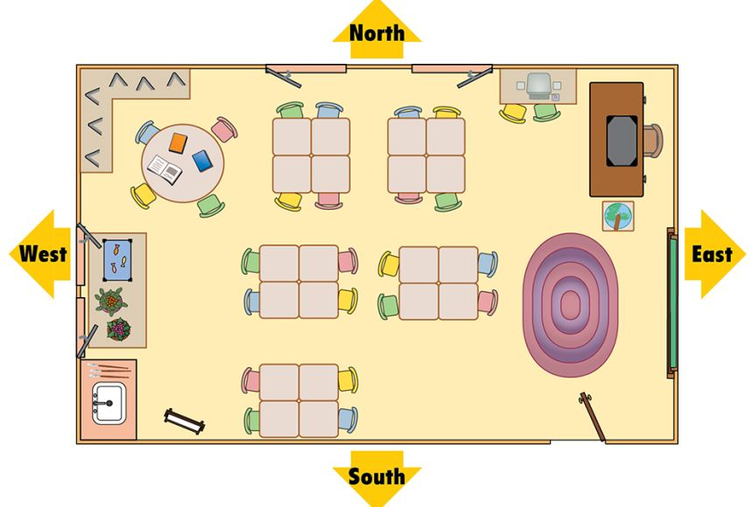

* 1. **Math Bingo**

**Description: Create bingo cards with math problems, and the answers are the numbers on the card.**

**Materials: Paper, markers.**

**Time Duration: 30 minutes.**

**Video:** [**https://youtu.be/JCeNT9kNfXs?si=UUhOYouu8OQcB4z9**](https://youtu.be/JCeNT9kNfXs?si=UUhOYouu8OQcB4z9)

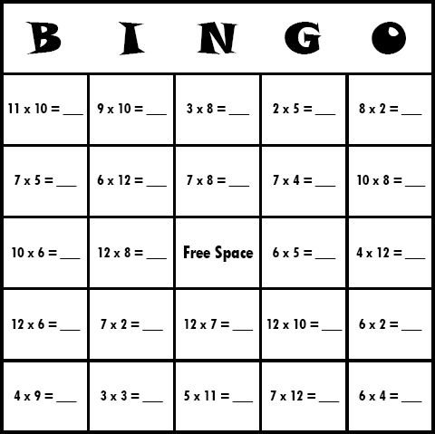

* 1. **DIY Sundial**

**Description: Make a sundial and learn about time and shadows.**

**Materials: Stick, paper plate, markers.**

**Time Duration: 40 minutes.**

**Video:** [**https://youtu.be/WcwdtNWZeys?si=ba7qgSznr7LnT3fM**](https://youtu.be/WcwdtNWZeys?si=ba7qgSznr7LnT3fM)

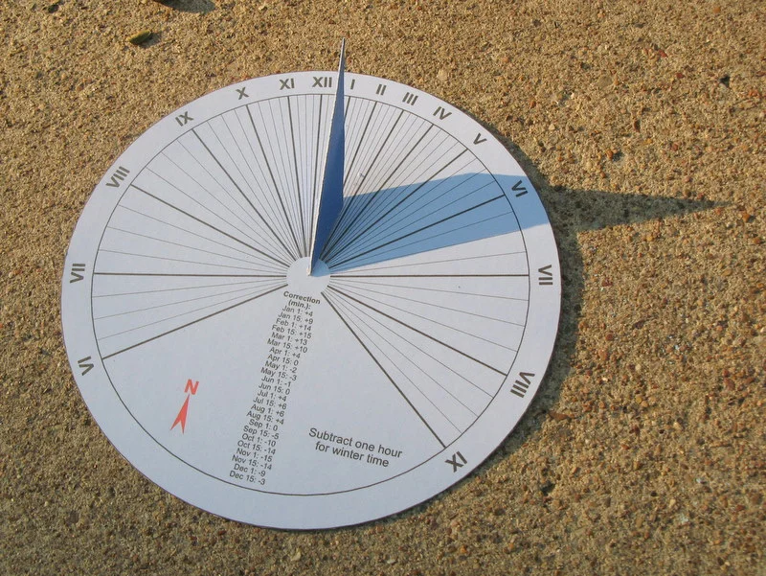

* 1. **Word Detective**

**Description: Hide clues with words around the house for the child to solve a puzzle.**

**Materials: Paper, pen.**

**Time Duration: 30 minutes.**



* 1. **Reading Relay**

**Description: Take turns reading pages of a book and discussing new words.**

**Materials: A storybook.**

**Time Duration: 20-30 minutes.**

**Video:** [**https://youtu.be/_Q3BhtL62WQ?si=feZ_ti1a4WQZWoWk**](https://youtu.be/_Q3BhtL62WQ?si=feZ_ti1a4WQZWoWk)

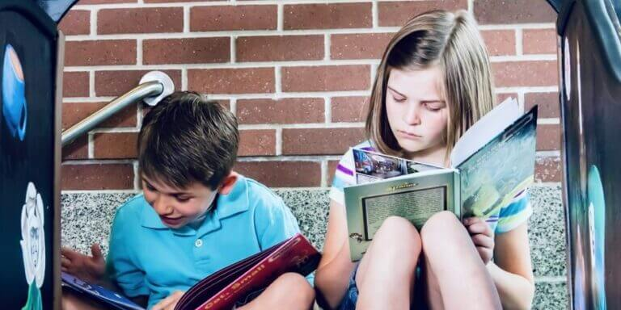

* 1. **Fraction Pizza**

**Description: Create a pizza and divide it into fractions to learn math.**

**Materials: Paper, crayons, or real ingredients.**

**Time Duration: 30 minutes.**

**Video:** [**https://youtu.be/vYXGwUhnXpw?si=RGfzZ0R2o4efVvT_**](https://youtu.be/vYXGwUhnXpw?si=RGfzZ0R2o4efVvT_)

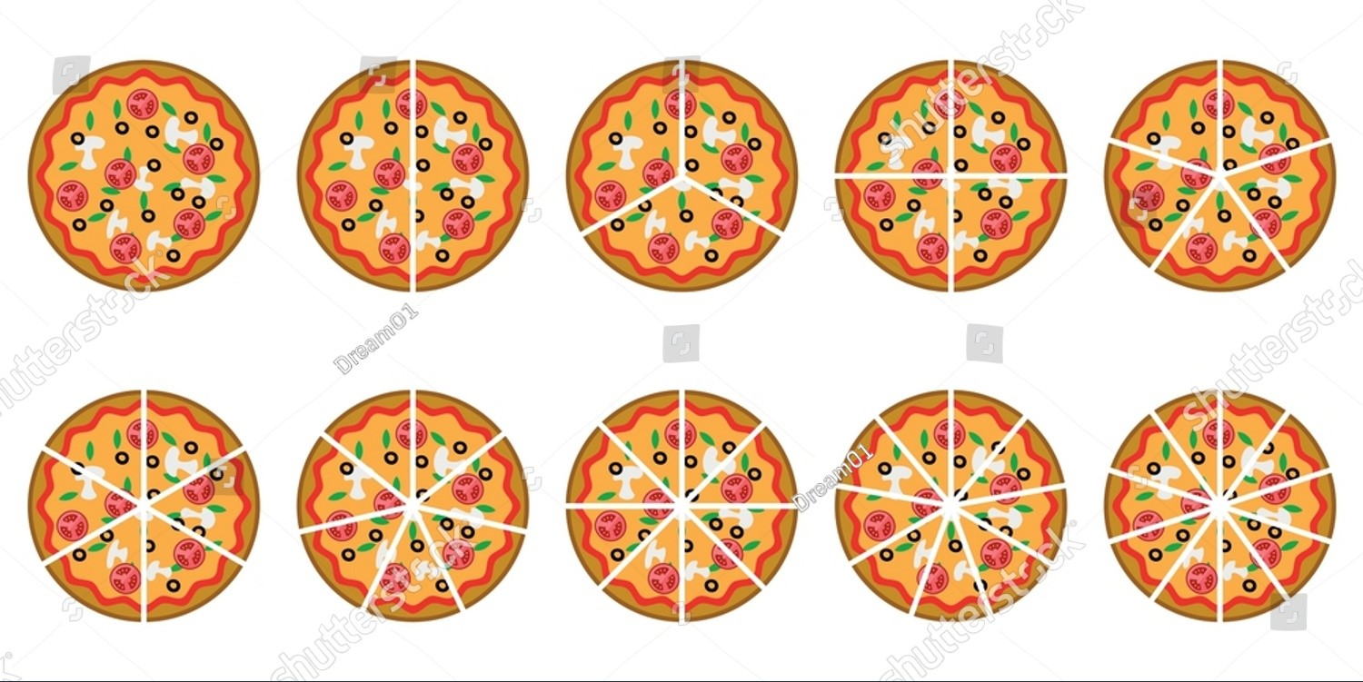

* 1. **Mirror Symmetry Drawing**

**Description: Draw one half of an object and let the child complete the other half symmetrically.**

**Materials: Paper, pencil, ruler.**

**Time Duration: 20 minutes.**

**Video:** [**https://youtu.be/pMOJ47KTFD0?si=02PL3cBkYpLyHNqc**](https://youtu.be/pMOJ47KTFD0?si=02PL3cBkYpLyHNqc)

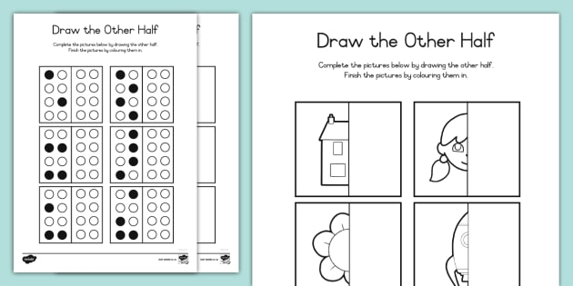

* 1. **Spelling Tower**

**Description: Build a tower of blocks with letters to spell words.**

**Materials: Letter blocks or cubes.**

**Time Duration: 20 minutes.**

**Video:** [**https://youtu.be/B7-B3X8Fzh4?si=UZF1IFgj1w4NYwvt**](https://youtu.be/B7-B3X8Fzh4?si=UZF1IFgj1w4NYwvt)

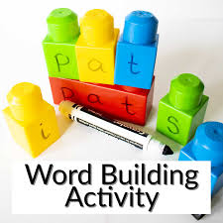

* 1. **Time Capsule**

**Description: Create a time capsule with drawings, notes, and objects to open later.**

**Materials: Box, paper, markers.**

**Time Duration: 40 minutes.**

**Video:** [**https://youtu.be/9xdP17L8gqw?si=Q_V2z2RYURinEo5U**](https://youtu.be/9xdP17L8gqw?si=Q_V2z2RYURinEo5U)

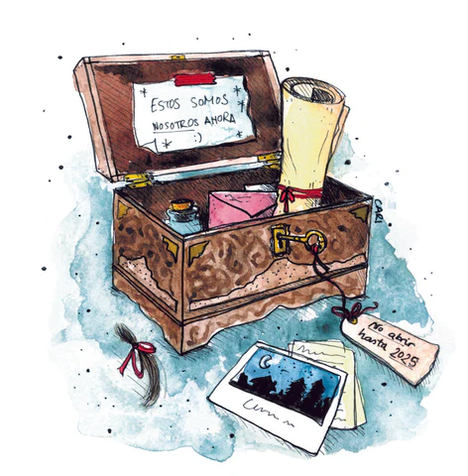

* 1. **Shadow Art**

**Description: Place objects in sunlight and trace their shadows to make art.**

**Materials: Paper, pencil, objects.**

**Time Duration: 25 minutes.**

**Video:** [**https://youtu.be/m__0z5Cj4Sk?si=WSX5_a7-YrE_hpER**](https://youtu.be/m__0z5Cj4Sk?si=WSX5_a7-YrE_hpER)

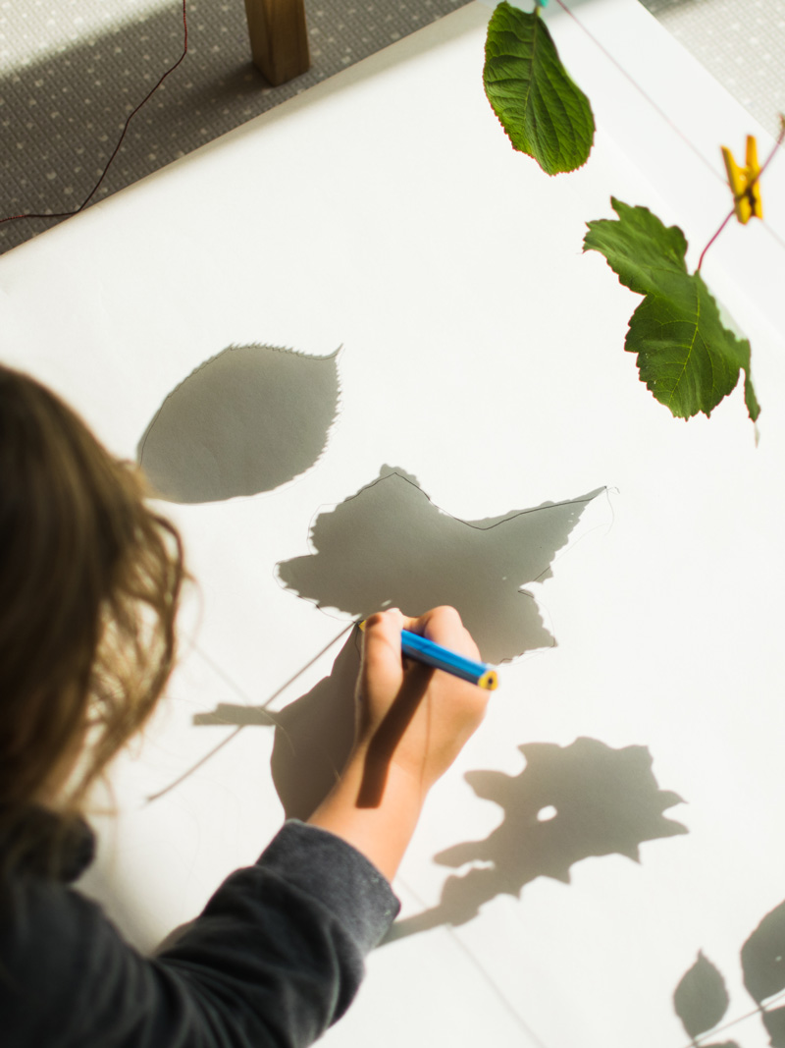

* 1. **Budget Shopping Game**

**Description: Give the child a pretend budget and a list to buy items in a pretend shop.**

**Materials: Fake money, household items as shop items.**

**Time Duration: 30-40 minutes.**

**Video:** [**https://www.youtube.com/shorts/M4BdclOf4Iw**](https://www.youtube.com/shorts/M4BdclOf4Iw)

